# Defining the Question (The Problem Statement).

During the Fiscal Year 2022-23, there was a huge public outcry regarding the state of Non-Performing Loans (NPLs) in the banking sector in Nepal. The purpose of this analysis is to figure out the state of loans provided by the BFIs in Nepal. Further, the study tries to find out the following:

* The proportion of fixed and current asset-based loans in the industry. The higher the proportion of fixed asset-backed loans, the lower the chance of banks being insolvent.
* To figure out the change in business models of individual banks. Significant changes in the proportion of loans to different sectors indicate a bank’s interest in a specific industry.
* To find out the change in DSL (Deprived Sector Lending). We required this to assess the change in loans given to the Microfinance industry.

# Collecting the Data.

Data was collected from Nepal Rastra Bank’s website. Nepal Rastra Bank or NRB is the central bank of Nepal. <https://www.nrb.org.np/category/monthly-statistics/?department=bfr>

**Time period of the study:** July 2013 to Feb 2023

**Background**: NRB publishes provisional Banking and Financial Statistics each month. Each publication is around 60 pages long and contains details of financial statements of loans and deposits of individual and industry-wise data of Commercial Banks, Development Banks, Finance Companies, and only industry-wise data of Microfinance Institutions.

Before July 2021, only pdf files were uploaded. We have converted the pdf files to Excel files using [www.ilovepdf.com](http://www.ilovepdf.com), and kept in a folder.

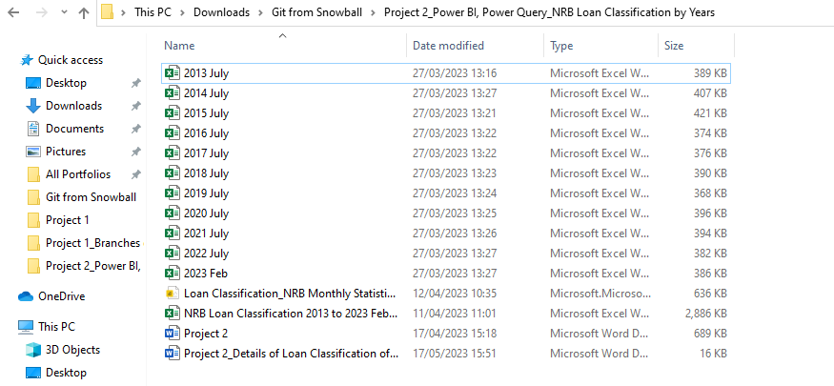

Following is a snapshot of the data from the central bank’s website.

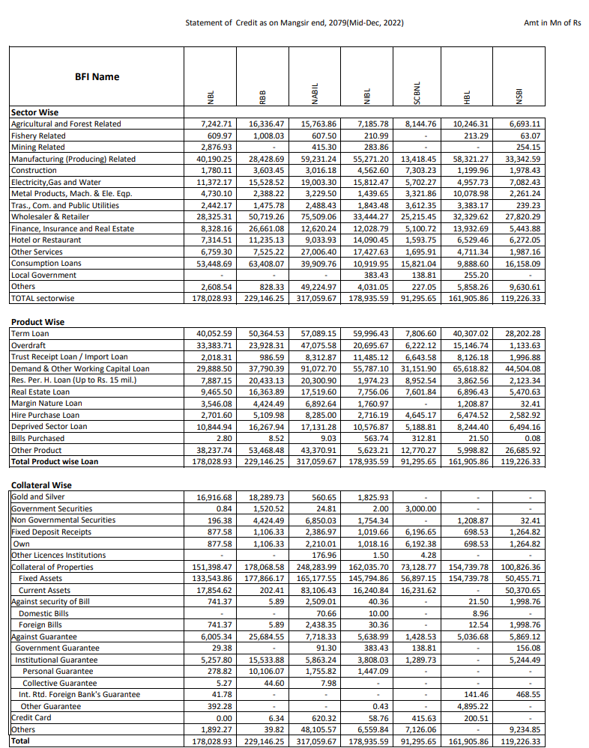

# Cleaning the Data.

Each of the 11 Excel files had at least 40 tables. Only 10-15 tables were required for our study.

Macros were used initially to convert the tables into Excel recognizable tables and nomenclature was given to each table as “Table**N**”, where “N” stands for 1,2,3…., N.

This nomenclature was required to distinguish the tables required for the study from other tables.

All 11 Excel files were loaded in a new Excel file using **Power Query**.

Only required tables were selected for the study using:





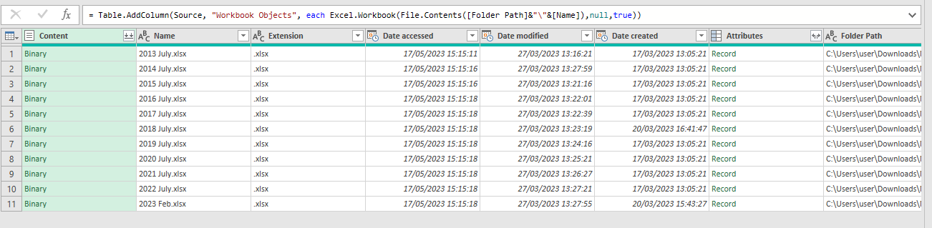

The following steps were used to clean the data:

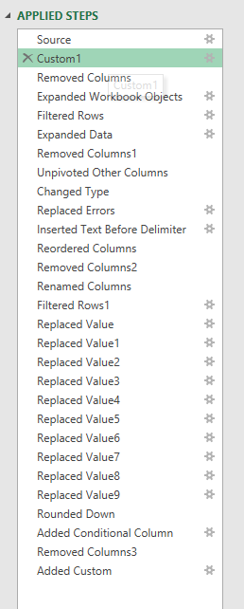

Multiple “Replaced Value” was used to filter out the non-listed, merged, or acquired banks.

Finally, the data were transformed into five columns and 33,908 rows. It was then loaded to the Excel sheet and added to the data model.

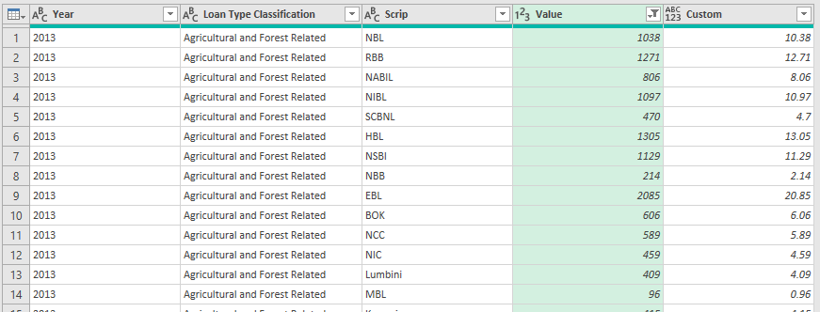

Following relationships were created among the three tables based on a primary fields “Scrip” and “Loan Type Classification”.

# Analyzing the Data.

**Pivot Tables** were used to analyse various useful trends.

# Visualizing the Data.

A Dynamic visualization was possible using **Pivot Charts and Power BI** and the questions defined in the problem statement were answered.

* 80% of loans from Commercial banks, Development banks, and Finance companies were backed by Fixed assets-based collateral. This indicates a strong position of banks in Nepal to recover losses as they are mostly backed by fixed assets.

* We saw a change in NIC Asia Bank’s business model from wholesale to retail from 2017 onwards as fixed assets-backed loans started to shoot up while the current assets-backed loans continued to decline.

* We figured out that the DSL, which was in increasing trend from 2013 to 2022, declined by 1,500 crores in Feb 2023. This might have negative implications for microfinance companies in the years to come.

**Dashboard in Excel:**

**Dashboard in Power BI:**

